Advantage Africa Partners’ Workshop
Handout 12.3 Analysed Cash and Bank Book Practice

- Use the information below to complete the analysed bank and cash book for the fictitious organisation Training for Development.
Some of the information has already been included
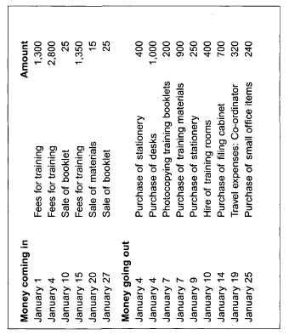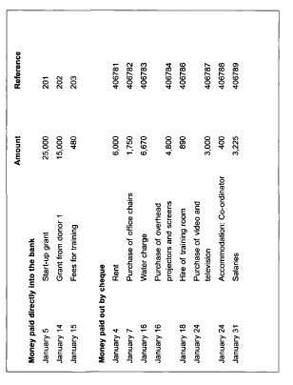

Training for Development analysed cash and bank book (income side)
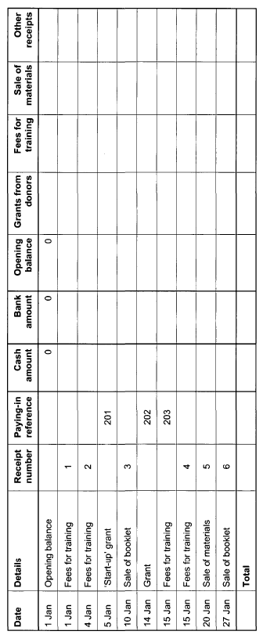

Training for Development analysed cash and bank book (expenditure side)
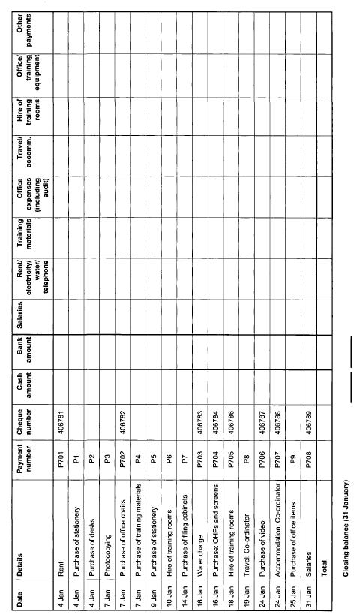

2. In February, Training and Development had the following transactions. Record these transactions in the cash and bank book below

